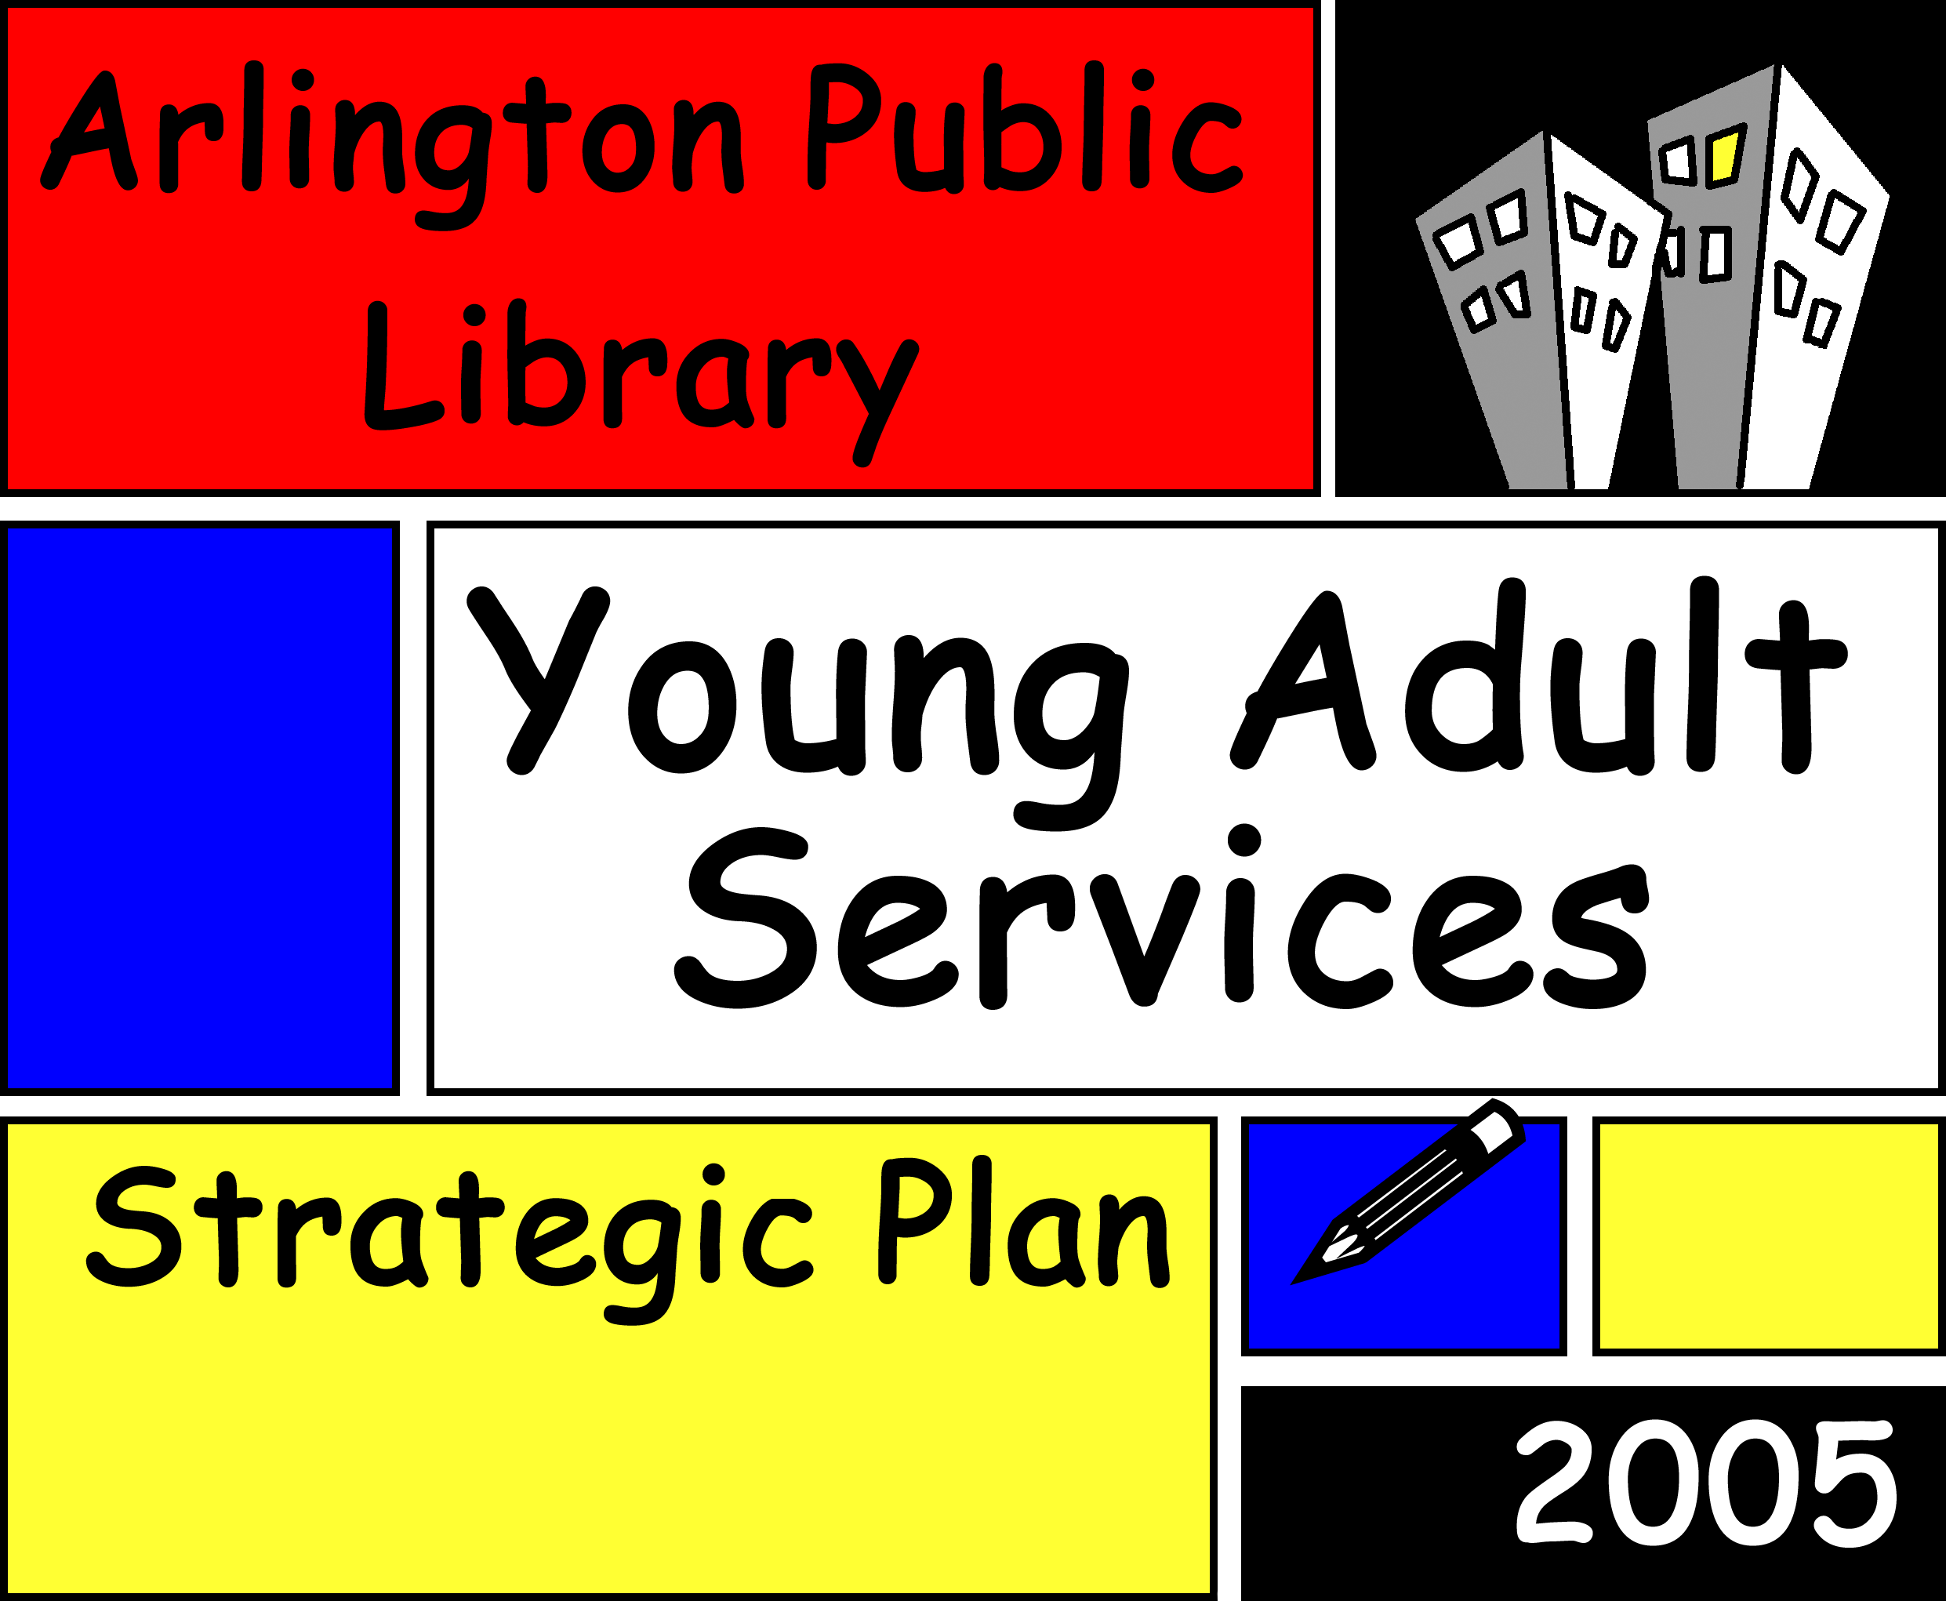
Prepared by Deirdre Stretton, May 3, 2005

Introduction
Empowerment through Learning
This strategic plan addresses the needs and goals of the Young Adult Services Department (YASD) for the next three years. The department serves the information needs of 12-18 year olds in the local community. Teenagers are a vital and important part of our community that is often neglected. These are our next voters, work force, politicians, doctors and librarians! We need to do all we can to ensure that they succeed.

Mission Statement
Empowerment through Learning

Vision

The vision of the Young Adult Services Department is to encourage life-long learning, stimulate creativity, and help prepare adolescents for the transition into the adult world.

Core Values
- Empowerment. To provide teens with the tools they need to feel empowered in their personal and academic lives.
- Integrity. To be honest with teens and straightforward in our service of all their information needs.
- Advocacy. To work with and for teens to ensure that their needs are being met both by the library and in the community at large.
- Encouragement. To encourage teens to follow their natural interests and begin the process of life-long learning.
- Service. To provide teens with their information needs without judgment or censorship.

Goals
What do we want to accomplish?
Empowerment through Learning

  - Goal 1. To be advocates for teens and teen services that will empower youth to succeed in the transition into adult life.
  - Goal 2. To create a welcoming space for all teens that will encourage them to use the library regularly.
  - Goal 3. Create programs to attract and aide at-risk teen patrons who do not normally use the library.

Partners
Who do we need to work with effectively to achieve our goals?
- Teenagers!
- High school faculty and professionals, such as health services employees, school media center librarians, and teachers
- Community organizations, such as YMCA and social service agencies
- Library director, staff and the library board
- Parents

Advocacy
How do we know what teens want and need from the library? Ask them!
- User surveys will go on the website, in the library and the school library to find out what teens think of the library, what they want to be improved, and what they think it’s lacking.
- Exit surveys will accompany every program to get feedback and make improvements

Create a New Space!
Teens need their own space, separate from younger children, where they will want to go, hang out and learn! In order to do this we’ll make the following improvements.
- Add couches for comfortable reading, another work table for homework space, and curtains to separate the space from other areas
- Add two Internet computers and one OPAC machine for research help
- Create new and colorful signs that make it a fun space!

Programs for Teens
Empowerment through Learning
The library wants to empower teens though programs that encourage them and improve their lives.
- Graphic novels! These are very popular with teens, and a program to create them will get teens through the door and exposed to all that the library offers. Not only that, but they’ll get the encouragement and sense of accomplishment from creating and expressing themselves. Local artists and writers will be involved to help run the program, and the art department in the high school will market the program to potential participants.
- Domestic violence. Domestic violence is an issue facing many young people and their families. Creating a panel to talk about the issues, providing the school health center with information, working with community organizations to create a self defense program to both empower and protect teenage girls all will support those facing domestic violence.

How Do We Measure Success?
- The user needs survey will be reviewed every six months to make sure that the needs of the community are continuing to be met.
- Exit surveys will be administered after all programs
- Circulation of the teen collection will be monitored
- Success is never truly achieved!

Where Do We Go from Here?
The needs of teens will always need to be addressed with each coming generation. It is important that dedicated space and resources be set aside so we can continue to meet the needs of this complex group.

